
Blue Team Shooting Sports A.S.S.S. March 24th. 2026
COURSE DESIGNER: Ike Starnes

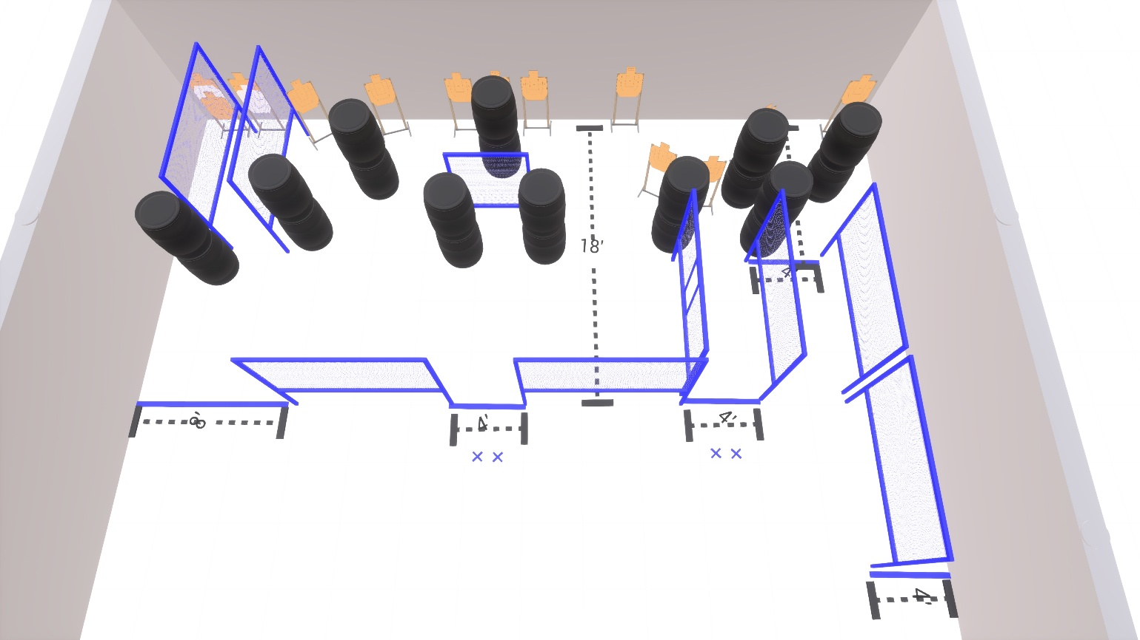

Written Stage Briefings:

Stage 2 – Second things second - is a 26-round, 130 point, Comstock Course. There are 13 cardboard targets. The best 2 hits per cardboard target will be scored.
Handgun start position Feet on either set of Xs. The handgun is unloaded and holstered.
PCC start position Feet on either set of Xs. PCC is unloaded with stock touching belt.
On the audible start signal, engage all targets from within the shooting area.

